Rashtreeya Sikshana Samithi Trust
RV UNIVERSITY
School of Computer Science and Engineering
Bengaluru – 560059



Lab Record
CS3234 - Foundations of Generative AI

VI SEMESTER B.Tech (Hons.)

Cybersecurity and Ethical Hacking Fundatmentals– Documentation
Name: Shashi Kumar R
Program: BTech CSE
Institution: R V University
Workshop Date: 15/02/2026
Time: 10:00 AM – 4:00 PM

1. Objective
To demonstrate an end-to-end workflow using Generative AI tools to create promotional content for a workshop, including:
- Launch email (text)
- Workshop poster (image)
- Promo video (video)

2. Tools Used
- ChatGPT / Gemini / Claude – email and text generation
- DALL-E / Image Creator – poster generation
- Fliki.ai – text-to-video promo creation
- Kaleido.ai – animated reel creation (optional)

3. Prompts Used

Prompt 1: Launch Email (ChatGPT/Gemini/Claude)
Act as a professional academic coordinator and cybersecurity education expert. Create a formal workshop launch email suitable for academic circulation.
Workshop Topic: Ethical Hacking and Network Security Basics
Target Audience: Undergraduate students and working professionals
Duration: One-day (6 hours)
Mode: Offline
Location: Bengaluru
Level: Beginner (no prior hacking, cybersecurity, or programming knowledge required)
The email must clearly include:
- Workshop objective and academic relevance
- Career importance of cybersecurity skills
- Date, time, mode, and location of the workshop
- Key topics covered (ethical hacking fundamentals, cyber threats, network security basics, introductory hands-on tools, career pathways)
- Registration details with a clear mention of limited seats
- Contact information (generic placeholders allowed)
Tone and Style Requirements:
- Professional, formal, and motivating
- Suitable for universities and academic institutions
- Avoid casual or promotional language
- Ensure clarity, structure, and credibility
Format and Length:
- Paragraph-based formal email
- Word limit: 180–200 words
- Clear opening, informative body, and polite academic closing

Prompt 2: Poster Creation (DALL-E / Image Creator in Chatgpt)

Create a high-resolution, professional digital poster for a university-level technical workshop titled “Cybersecurity & Ethical Hacking Fundamentals.”
Poster Content (Clearly Visible Text)
- Workshop Title: Cybersecurity & Ethical Hacking Fundamentals
- Date: 25th March 2026
- Time: 10:00 AM – 4:00 PM
- Mode: Online Workshop
- Organized by: Department of Computer Science and Engineering
Scene Description
Depict undergraduate engineering students working on laptops in a modern computer lab or virtual classroom environment, with cybersecurity dashboards and code visible on screens, representing online technical learning.
Visual Elements
- Cybersecurity-themed graphics including digital locks, shields, firewalls, encrypted code, network diagrams, and security icons
- Abstract visual representation of ethical hacking, intrusion detection, and security monitoring
- Subtle binary code patterns and digital network lines in the background
Design Constraints
- Professional academic and official university appearance
- Clean poster-style layout suitable for college notice boards and online promotion
- Blue and dark-blue color palette with subtle glowing cyber highlights
- Modern, futuristic technology aesthetic
- Balanced composition with clean typography and clear hierarchy
- High-resolution output with sharp text and visuals
Overall Tone
Formal, trustworthy, and educational, designed for official university promotion and student outreach.

Prompt 3: Promo Video Script (Fliki.ai)
Video Style: Professional, academic, technology-focused
Tone: Formal, informative, motivating
Audience: Undergraduate students & working professionals
Duration: 60–90 seconds

Scene 1 – Opening (Cyber Theme Introduction)
Visual: Abstract cybersecurity visuals, digital locks, network lines, code flowing
Voiceover:
"Cybersecurity has become a critical skill in today’s digital world. With increasing cyber threats, understanding ethical hacking and network security is more important than ever."

Scene 2 – Workshop Announcement
Visual: Students and professionals working on laptops, classroom or seminar visuals
Voiceover:
"We are pleased to announce a one-day offline workshop titled Ethical Hacking and Network Security Basics, designed for beginners and aspiring cybersecurity professionals."

Scene 3 – Target Audience
Visual: University students, IT professionals, group learning environment
Voiceover:
"This workshop is open to undergraduate students and working professionals. No prior knowledge of hacking, cybersecurity, or advanced networking is required."

Scene 4 – Workshop Objective
Visual: Shield icons, secure servers, ethical hacker illustrations
Voiceover:
"The objective of this workshop is to provide a strong foundation in ethical hacking concepts, common cyber threats, and essential network security practices."

Scene 5 – Key Topics Covered
Visual: Icons or animations for attacks, networks, tools, career paths
Voiceover:
"Participants will learn the fundamentals of ethical hacking, types of cyber attacks, basic network security mechanisms, hands-on exposure to security tools, and career pathways in cybersecurity."

Scene 6 – Date, Time & Location
Visual: Calendar animation, clock, Bengaluru city visuals
Voiceover:
"The workshop will be held on Saturday, 15th February 2026, from 10 AM to 4 PM, as an offline session in Bengaluru."

Scene 7 – Call to Action
Visual: Registration button animation, limited seats highlight
Voiceover:
"Seats are limited. Interested participants are encouraged to register early to secure their spot."

Scene 8 – Contact Information & Closing
Visual: Email and phone icons, professional closing slide
Voiceover:
"For more information, contact us at shashir@gmail.com Join us and take your first step into the world of ethical hacking and network security."

5. Outputs (Attach or Insert)
- Launch Email: (paste email text here)
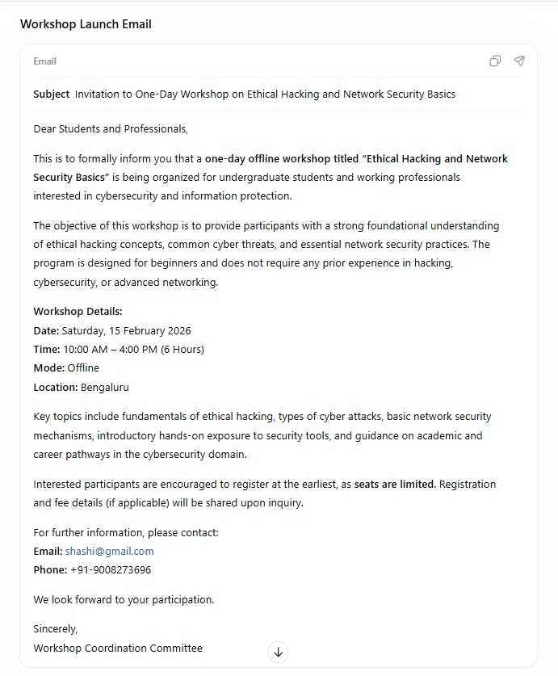

- Poster Image:


- Promo Video:
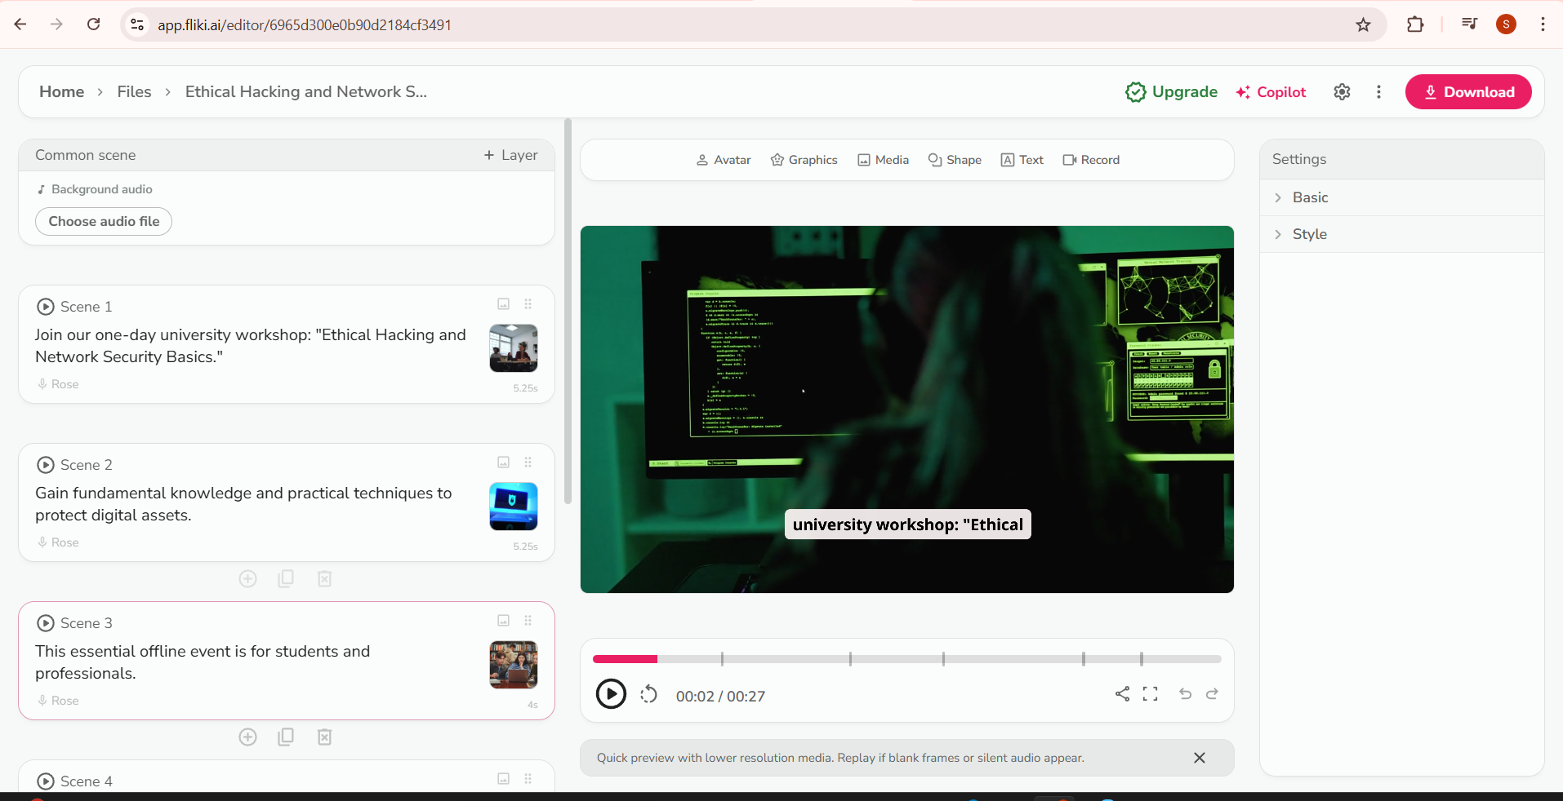

6. Conclusion
This documentation shows how Gen-AI tools can be used to generate text, image, and video assets for academic workshop promotion in an efficient and structured way.

